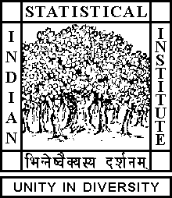

Theoretical Statistics and Mathematics Unit

Seminar

Date: June 20, 2019 Time: 04:15 P.M.

Venue: L-infinity, Stat-Math Unit (5th Floor, A.N. Kolmogorov Bhavan)

Priyanka Sen
ISI Kolkata

Spectral Analysis of Non-Hermitian Random Matrices: a Review

Abstract

It is difficult to establish the asymptotic behaviour of the spectral distribution on non-Hermitian matrices when the dimension grows. We shall give an expository account of some methods that have been found useful in this area. In particular we shall discuss a few models where limit results have been proved.

ALL ARE CORDIALLY INVITED

