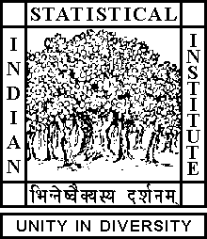

Theoretical Statistics and Mathematics Unit

Thesis Proposal Presentation

Date: July 16, 2019 Time: 03:00 P.M.

Venue: L-infinity, Stat-Math Unit (5th Floor, A.N. Kolmogorov Bhavan)

Sourjya Banerjee
ISI, Kolkata

Complete intersection ideals as section of Projective modules and orbit space of unimodular elements of a line bundle

Abstract

This is a rough outline of the project to be pursued towards the fulfillment of my thesis work. It gives a brief overview of some classical problems and some recent developments in the area of Projective modules and complete intersection ideals. In the first part we'll discuss the question asked by Nori on the section of a Projective module and in the remaining two parts we'll discuss on the the injectivity of the Vaserstein's symbol and the group structure of the van der Kallen group respectively.

ALL ARE CORDIALLY INVITED

