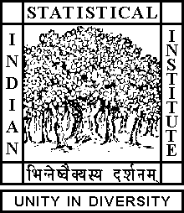

Theoretical Statistics and Mathematics Unit

Thesis Presubmission Seminar

Date: July 15, 2019 Time: 04:15 P.M.

Venue: L-infinity, Stat-Math Unit (5th Floor, A.N. Kolmogorov Bhavan)

Joydeep Chowdhury
ISI, Kolkata

Nonparametric Regression and ANOVA in Infinite Dimensional Spaces

Abstract

In my thesis, I have investigated and developed nonparametric regression methods, where either one or both of the response and the covariate are infinite dimensional in nature. I have also studied and developed a method of analysis of variance with infinite dimensional data. The thesis has four main chapters. In the first chapter, the convergence rate and its optimality of nonparametric kernel regression estimates for a large class of population parameters are investigated, where both the response and the covariate are infinite dimensional. In the second chapter, methods of nonparametric quantile regression are developed and their utilities are discussed for the response lying in a Banach or Hilbert space and an infinite dimensional covariate. In the third chapter, regression methods based on statistical depths are described. Finally, in the fourth chapter, an ANOVA method for Hilbert space valued random elements are developed based on spatial ranks and its performance is compared with existing mean-based tests.

ALL ARE CORDIALLY INVITED

