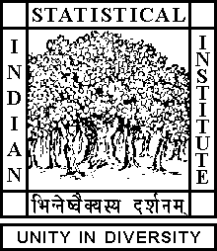

Theoretical Statistics and Mathematics Unit

Seminar

Date: June 19, 2019 Time: 04:15 P.M.

Venue: L-infinity, Stat-Math Unit (5th Floor, A.N. Kolmogorov Bhavan)

Biltu Dan
ISI Kolkata

The scaling limit of some random interface models

Abstract

We study the scaling limit of the interface model on the d-dimensional integer lattice, where the Hamiltonian is given by a mixed gradient and Laplacian interaction. We show that in any dimension the scaling limit is given by the Gaussian free field and discuss the appropriate spaces in which the convergence takes place. We use some discrete PDE techniques of elliptic boundary value problems. This is a joint work with Alessandra Cipriani (TU Delft) and Rajat Subhra Hazra (ISI Kolkata).

ALL ARE CORDIALLY INVITED

