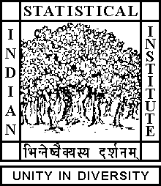

Theoretical Statistics and Mathematics Unit

Student Seminar

Date: July 15, 2019 Time: 02:30 P.M.

Venue: L-2, Stat-Math Unit (2nd Floor, A.N. Kolmogorov Bhavan)

Biman Roy
ISI, Kolkata

The proof of Paley-Wiener Theorem

Abstract

ALL ARE CORDIALLY INVITED

