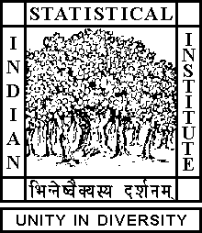

Theoretical Statistics and Mathematics Unit

The Graduate Seminar

Date: July 11, 2019 Time: 02:00 P.M.

Venue: L-infinity, Stat-Math Unit (5th Floor, A.N. Kolmogorov Bhavan)

Aritra Ghosh
ISI, Kolkata

A result on natural numbers

Abstract

There exist infinitely many integers n such that both n and n+2 have at most 7 prime factors.I'll sketch a proof of this and if time permits we'll see a little improvement that there exist infinitely many primes p such that p+2 is a number having at most 8 prime factors.

ALL ARE CORDIALLY INVITED

