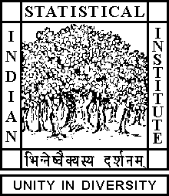

Theoretical Statistics and Mathematics Unit

Seminar

Date: July 26, 2019 Time: 12:10 P.M.

Venue: L-infinity, Stat-Math Unit (5th Floor, A.N. Kolmogorov Bhavan)

Partha Sarathi Ghosh
M. Math. ISI, Kolkata

Weekly seminar on Riemann surfaces

Abstract

We will be running a weekly seminar on compact Riemann surfaces, mainly following Forster's book. Topics to be covered include: dbar equation and Dolbeault lemma, sheaves and sheaf cohomology, Leray's theorem, short exact sequences of sheaves and long exact sequence in cohomology, Dolbeault theorem, de Rham theorem, Hodge theorem, finite dimensionality of cohomology groups, Riemann-Roch theorem and its applications, embeddings into projective space via ample divisors, Serre duality theorem, Mittag-Leffler problem for meromorphic functions and 1-forms with prescribed principal parts.

ALL ARE CORDIALLY INVITED

