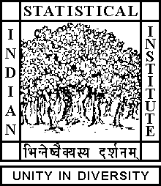

Theoretical Statistics and Mathematics Unit

Seminar

Date: February 07, 2020 Time: 02.00 P.M.

Venue: L-infinity, Stat-Math Unit (5th Floor, A.N. Kolmogorov Bhavan)

Debanil Dasgupta
ISI Kolkata

Quillen's theorem on the universal formal group law

Abstract

Quillen's theorem states that the complex cobordism ring is isomorphic to the Lazard ring, which is the universal ring for formal group laws. We will convey how formal group laws are naturally associated to certain generalized cohomology theories, and their use in the complex cobordism case.

ALL ARE CORDIALLY INVITED

