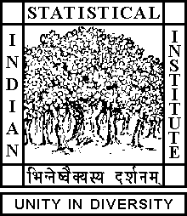

Theoretical Statistics and Mathematics Unit

Seminar

Date: July 10, 2019 Time: 04:15 P.M.

Venue: L-infinity, Stat-Math Unit (5th Floor, A.N. Kolmogorov Bhavan)

Sukrit Chakraborty
ISI, Kolkata

Largest eigenvalue of in-homogeneous Erdos-Renyi random graph

Abstract

We shall discuss about the limiting behaviour of the largest eigenvalue of the adjacency matrix of an in-homogeneous Erdos-Renyi random graph. We shall show that in certain cases after appropriate centering and scaling the largest eigenvalue converges in distribution to a Normal random variable. The talk is based on an on-going work with Arijit Chakrabarty and Rajat Subhra Hazra.

ALL ARE CORDIALLY INVITED

